Oakland Undercurrent Swim Team Fall 2015 Grant Update:
For the Fall,2015 and Winter 2016, Oakland Community Pools Project was able to subsidize five families who have 10 swimmers on the swim team. Our team continues to be very diverse. It is 30% African-American, 30% Hispanic, 30% Asian, 5% Caucasian and 5% biracial. Our swimmers had excellent attendance at practice and have participated in 3 - 5 swim meets since November. All of these swimmers improved their times and continue to take advantage of the opportunities provided through the scholarship program. OCPP plans to work with other agencies and schools to involve more minorities in swimming.
We continue to provide scholarships to all swimmers who request one. We have applied for grants to the Olympic Club Foundation and California Wellness. We have received $10,000 from the Olympic Club. We continue to look for grants that support athletic teams. Our mission has and continues to be to reach swimmers who are underrepresented in USA Swimming.
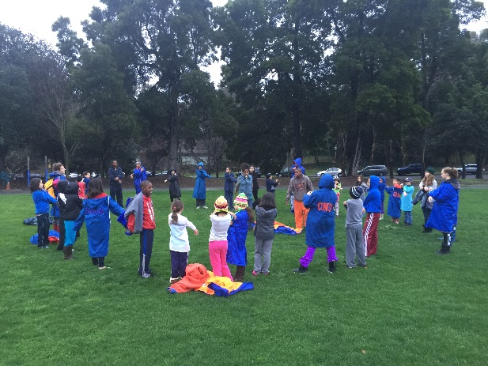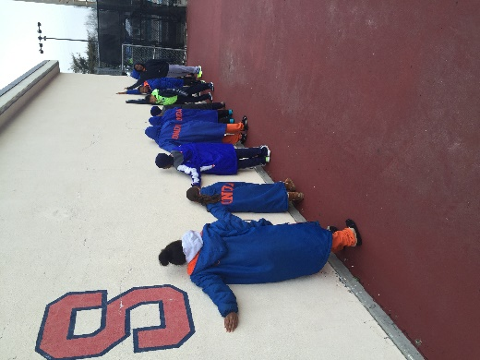

Thank you for all your support.

Rolandas Gimbutis
Head Coach
Oakland Undercurrent Swim Team

