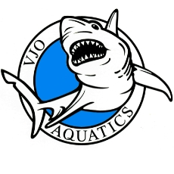
VALLEJO AQUATICS CLUB
John F. Cunningham Aquatic Center
801 Heartwood Ave.
P.O. Box 5846
Vallejo, CA 94589
707- 553-7946 (SWIM)
www.vallejoaquatics.org

Pacific Swimming Diversity and Outreach Grant Report 2017

The Board of Vallejo Aquatics would like to thank Pacific Swiming for the generous Diversity and Outreach Grant we received. We continue to strive to meet the needs of underserved and diverse youth in our community by providing opportunities for personal development, along with physical and emotional growth, through the sport of swimming.
This report documents Vallejo Aquatics utilization of the Diversity and Outreach Grant to engage diverse and underprivileged youth interested in the sport of swimming who would not otherwise be able to take advantage of these opportunities due to financial hardships.

- The Diversity and Outreach Grant was used to provide financial assistance to 6 new swimmers. Of the 6 swimmers who received assistance, one was Hispanic, four were African-American and one was African-American and Hispanic. One of the 6 swimmers funded by the grant was from a low income family
- The funding from the grant has helped increase awareness in the community by facilitating inclusion of swimmers from diverse backgrounds who, in turn, can refer friends and family members from similarly diverse backgrounds which will help grow Vallejo Aquatics as a diverse and inclusive swim club.

This support from Pacific Swimming is greatly appreciated.

Sincerely

Vallejo Aquatics Board

